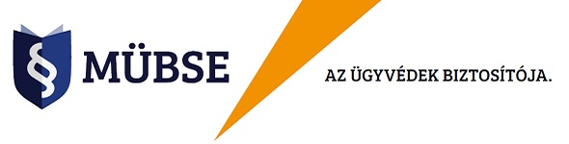

MÜBSE hírlevél
2023 november /2
Tisztelt Tagtársunk!
Amennyiben Ön elégedett Egyesületünk
- biztosítási termékeivel,
- az azokhoz kapcsolódó ügyfélszolgálati, kárrendezési munkánkkal és
- egyesületi szolgáltatásainkkal (támogatások, kreditszerzési lehetőség, ügyvédi balesetbiztosítás)
kérjük ajánlja a MÜBSE-t azon kollégáinak, akik még nem élvezik az Egyesületünk által kínált lehetőségeket!
Amennyiben ilyen kolléga a MÜBSE tagjává és biztosítottjává válik, és szerződésének díját legalább 1 évig fizeti, - továbbá Önt, mint ajánlót a szerződés megkötésekor megjelöli, - Önt 10%-os díjvisszatérítés illeti meg saját következő évi biztosításának díjából!
Az akció részleteit itt ismerheti meg.

Ezt a hírlevelet a következő email címre küldtük ki '%%emailaddress%%'
Leiratkozom a listáról!

%%companyname%%
%%companyaddress%%

